

BAŞKENT UNIVERSITY
ELECTRIC & ELECTRONICS ENGINEERING

EEM 214 ~ ELECTRONICS–I
LABORATORY
REPORT

Experiment Name : Zener Diode Characteristics
Experiment Number : 3

Student Name : Buğra BAYRAM
Student Number :20193272
Experiment Date/Day: 24 / 3 /2006
Laboratory Number:

Honor Pledge:

I did this preliminary work or lab report by myself and I have neither cheat from anybody nor let anybody cheat from me at the any part of this work.

Student Signature:
……………………….

Part I Zener Diode Test

1-)

Forward Biased |  | Reverse Biased
Vdiode | 1 | Vdiode | 0.7615

Part II Forward & Reverse Characteristics of Zener Diode

1-)

Diode Volts | Current in mA BZX55C
.35 | 0.25 µA
.45 | 2.18 µA
.55 | 20.94 µA
.60 | 52.21 µA
.65 | 143,23 µA
.70 | 1.0164 mA
.75 | 5.654 mA
.80 | 31.01 mA
.85 | -

When we forward bias zener diode,it acts as a normal diode.After 0.7 volts,it is on so it allows to flow current in the circuit.

2-)

V_{applied} in Volts | V_{zener} in Volts  (measured) | I_{diode} in mA  (measured)
2 | 2,064 V | -0,01 µA
3 | 3,114 V | -0,2 µA
4 | 4,079 V | 1,8 µA
5 | 5,15 V | 27,9µA
6 | 5,83 V | 373 µA
8 | 5,95 V | 6,46 mA
10 | 5,99 V | 12,33 mA
12 | 6,00 V | 18,34 mA
14 | 6,00 V | 24,26 mA

When we reverse bias zener diode,it goes down to the break down voltage after it’s zener voltage (6 Volts for this zener diode).It means that when zener is connected reverse to the circuit,after it’s zener voltage it gets to on position,it allows current to flow in the circuit.

3-)
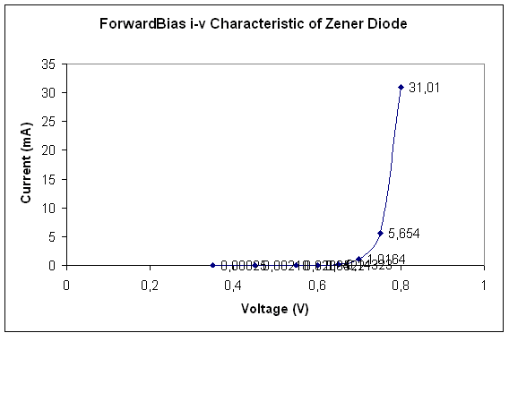
We see from this I-V characteristic,zener diode is same with the normal silicon diode in forward bias region.
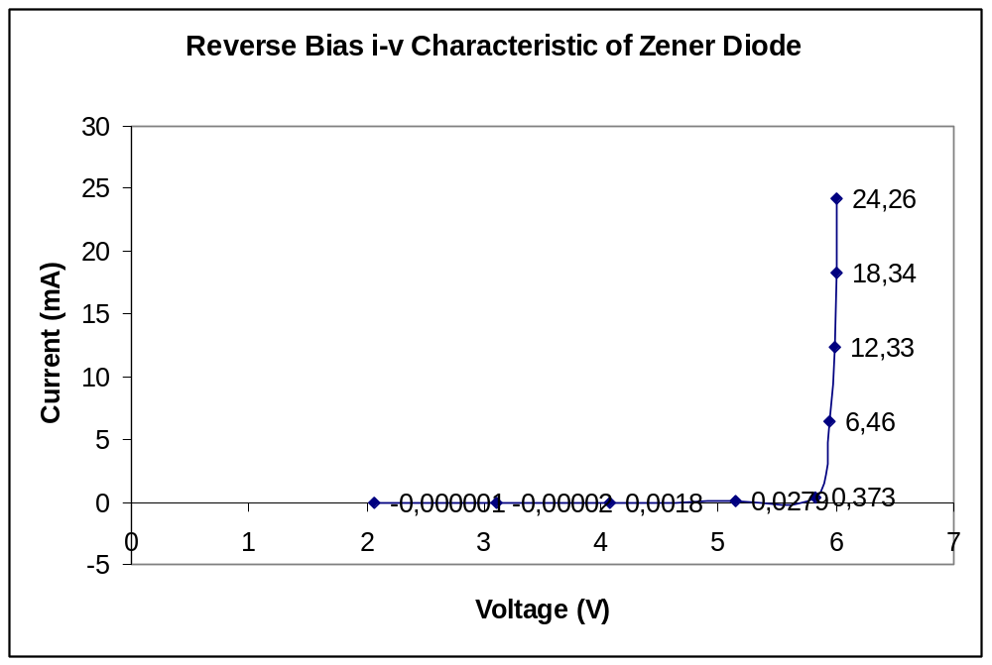
After it’s zener voltage,it goes to break down voltage,which means that voltage is constant at this value,current starts to flow across the zener dioe.

Summary : It is clear that from tables and graphs,zener diode is on after 0.7 V when forward bias as a normal diode.But zener diode is also on after its zener voltage (6 V for this zener) when reverse biased.

4-)
Zzener = Vzener / Izener

For 8V :
Zzener = 5,95 V / 6,46 mA = 0,921 K = 921 Ω

For 12V :
Zzener = 6,00V / 18,34 mA = 0,327 K = 327 Ω

Part III Zener Regulator

3-)
 | V_{L}
 | V_{S} = 15 |  | V_{S} = 8
 | R_{L} = 1.8 kΩ | R_{L} = 470 Ω | R_{L} = 1.8 kΩ | R_{L} = 470 Ω
R_{i} = 390 Ω | 5,98 V | 5,97 V | 5,92 V | 4,30 V
R_{i} = 220 Ω | 6,01 V | 6,01 V | 5,94 V | 5,42 V
R_{i} = 150 Ω | 6,05 V | 6,02 V | 5,96 V | 5,91 V
R_{i} = 100 Ω | 6,13 V | 6,07 V | 5,97 V | 5,98 V

4-)
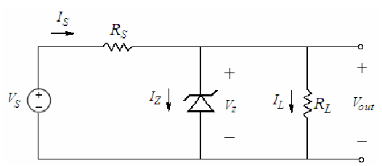
IL = Vout Is = Vs – Vout Is = Iz + IL
RL Rs Iz = Is – IL

Vs=15V:
RL = 1.8 K:
Rs= 390 Ω :

IL = 5,98 / 1,8 K = 3,32mA
Is = ( 15 – 5,98 ) / 0,39 = 23,1 mA

Iz = 23,1 – 3,32 = 19,78 mA
Vs=15V:
RL = 1.8 K:
Rs= 220 Ω :

IL = 6,01 / 1,8 K = 3,34mA
Is = ( 15 – 6,01 ) / 0,22 = 40,9 mA

Iz = 40,9 – 3,34 = 37,56 mA

Vs=15V:
RL = 1.8 K:
Rs= 150 Ω :

IL = 6,05 / 1,8 K = 3,36mA
Is = ( 15 – 6,05 ) / 0,15 = 59,7 mA

Iz = 59,7 – 3,36 = 56,34 mA

Vs=15V:
RL = 1.8 K:
Rs= 100 Ω :

IL = 6,13 / 1,8 K = 3,40mA
Is = ( 15 – 6,13 ) / 0,1 = 88,7 mA

Iz = 88,7 – 3,40 = 85,3 mA

Vs=15V:
RL = 470 Ω :
Rs= 390 Ω :

IL = 5,97 / 0,47 = 12,70mA
Is = ( 15 – 5,97 ) / 0,39 = 23,15 mA

Iz = 23,15 – 12,70 = 10,45 mA

Vs=15V:
RL = 470 Ω :
Rs= 220 Ω :

IL = 6,01 / 0,47 = 12,79mA
Is = ( 15 – 6,01 ) / 0,22 = 40,86 mA

Iz = 40,86 – 12,79 = 28,07 mA

Vs=15V:
RL = 470 Ω :
Rs= 150 Ω :

IL = 6,02 / 0,47 = 12,81mA
Is = ( 15 – 6,02 ) / 0,15 = 59,87 mA

Iz = 59,87 – 12,81 = 47,06 mA

Vs=15V:
RL = 470 Ω :
Rs= 100 Ω :

IL = 6,07 / 0,47 = 12,91mA
Is = ( 15 – 6,07 ) / 0,1 = 89,3 mA

Iz = 89,3 – 12,91 = 76,39 mA

Vs=8V:
RL = 1.8 K :
Rs= 390 Ω :

IL = 5,92 / 1,8 = 3,29 mA
Is = ( 8 – 5,92 ) / 0,39 = 5,33 mA

Iz = 5,33 – 3,29 = 2,04 mA

Vs=8V:
RL = 1.8 K :
Rs= 220 Ω :

IL = 5,94 / 1,8 = 3,3 mA
Is = ( 8 – 5,94 ) / 0,22 = 9,36 mA

Iz = 9,36 – 3,3 = 6,06 mA

Vs=8V:
RL = 1.8 K :
Rs= 150 Ω :

IL = 5,96 / 1,8 = 3,31 mA
Is = ( 8 – 5,96 ) / 0,15 = 13,6 mA

Iz = 13,6 – 3,31 = 10,29 mA

Vs=8V:
RL = 1.8 K :
Rs= 100 Ω :

IL = 5,97 / 1,8 = 3,32 mA
Is = ( 8 – 5,96 ) / 0,15 = 13,6 mA

Iz = 13,6 – 3,31 = 10,29 mA

Vs=8V:
RL = 470 Ω :
Rs= 390 Ω :

IL = 4,30 / 0,47 = 9,14 mA
Is = ( 8 – 4,30 ) / 0,39 = 9,49 mA

Iz = 9,49 – 9,14 = 0,35 mA

Vs=8V:
RL = 470 Ω :
Rs= 220 Ω :

IL = 5,42 / 0,47 = 11,53 mA
Is = ( 8 – 5,42 ) / 0,22 = 11,73 mA

Iz = 11,73 – 11,53 = 0,2 mA

Vs=8V:
RL = 470 Ω :
Rs= 150 Ω :

IL = 5,91 / 0,47 = 12,57 mA
Is = ( 8 – 5,91 ) / 0,15 = 13,9 mA

Iz = 13,9 – 12,57 = 1,33 mA

Vs=8V:
RL = 470 Ω :
Rs= 100 Ω :

IL = 5,98 / 0,47 = 12,72 mA
Is = ( 8 – 5,98 ) / 0,1 = 20,2 mA

Iz = 20,2 – 12,72 = 7,48 mA

